Country Research Project Worksheet

Name of Country: My Country’s Flag
The capital of my country is
The population of my county is

Geography
Popular cities located within my country:
My country is located on the continent of
My county is located in the _____________ hemisphere
Special landforms in the country
My country boarders

Climate
The climate in my country is
The average temperature in my county is

Famous People from my County
Name | Why are they famous

Industries/Natural resources

Important industries within my country are

Important natural resources within my country are

Culture
Languages that is spoken there
Special attractions within my country are

Holiday’s/Festivals/Celebrations
What are some of the Holiday’s Festivals and/or celebrations associated with this country

My country on a Map (Approximate)
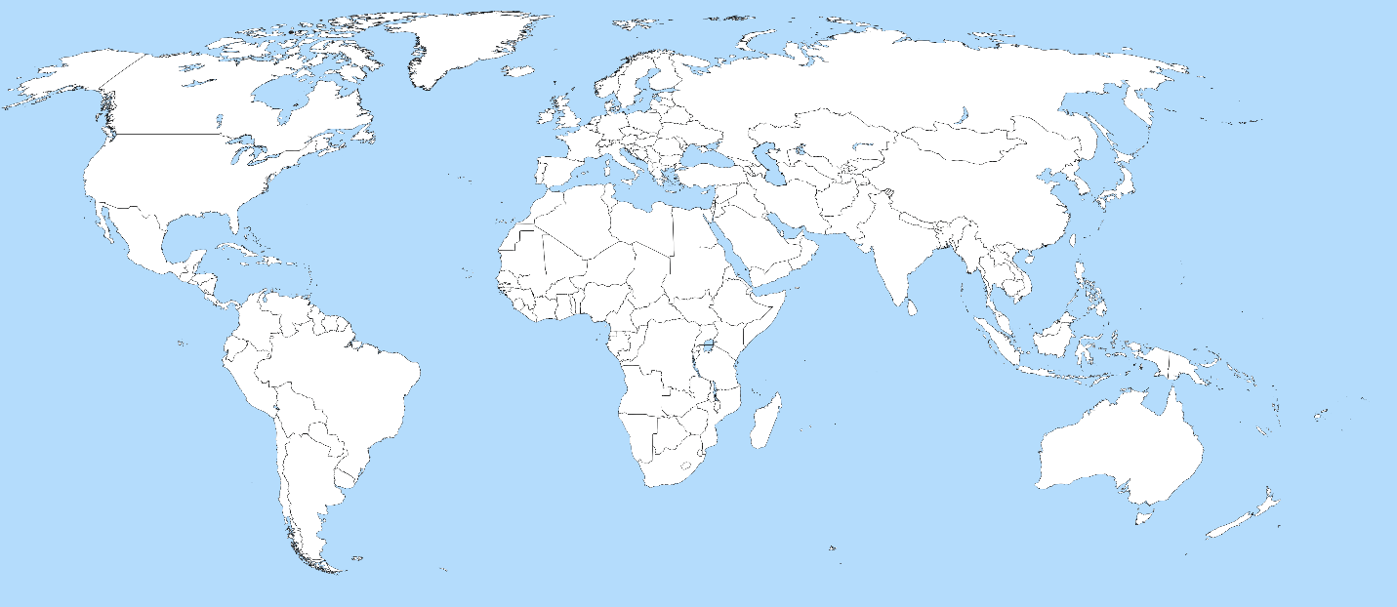

Resources Used | Special Notes

Country Project Directions:
Each quarter, students will take one of the countries of the Ancient Civilizations that we are studying and complete a research project using information of that country today.
At the start of each quarter, students will be given the choices of the countries as well as a review of the assignment. Students will use the attached worksheet as they research their country and the worksheet will be handed in.
Students have the option of creating a trifold or google slide show of their project. Students will present their country to the class.
Students will receive a hard copy of the directions and worksheet and they will also be available on our classroom website and in our Google Classroom.
One class period per quarter will be set aside for students to research in class, other wise this assignment is to be completed at home.

Due Dates:
First Quarter: Project due by: November 1st Presentations begin November 4th
Second Quarter: Project due by: January 18th Presentations begin January 20th
Third Quarter: Project due by: March 28th Presentations begin March 31st
Fourth Quarter: Project due by: May 31st Presentations begin June 2nd

Country Research Project Rubric
 | Possible Points | Student’s Points earned
Worksheet was neatly completed in its entirety | 10
Student used at least two different resources for project | 10
Poster/Google Slides Contained all parts of the worksheet required | 25
Poster/Google Slides were neatly displayed | 20
Poster/Google Slides contained pictures that were appropriate | 10
Project was completed on time | 10
Evident that student prepared for the presentation | 15

Points Earned: ______________________/100

Comments:

